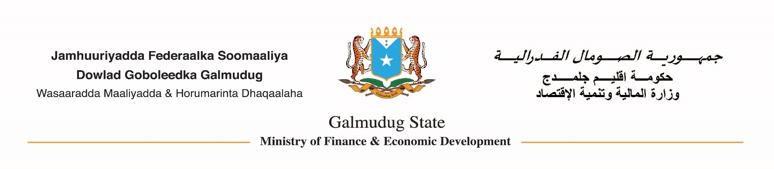
Narrative Report from 01/01/2107 to 31/03/2017
Galmudug State of Somlia
Ministry of finance an Economic Development
Adado, Somalia
30/04/2017

Introduction:
The Galmudug state of Somalia EAFS unit is in charge to implement the RCRF II project at the state level. Since our office was established at the end of last year, our tasks included reporting financial payments, maintaining financial control, process payment and communicate with EAFS/FGS unit to share the information regarding the RCRF II project. GSS want to use the all project components to support government functions in MDAs, but as of now, we use component two only where we started to disburse and covered the salary arrears for government civil servants employees that have accrued since July 2016. We have put on our agenda to pay the government operation costs (bills) through our TSA and seek reimbursement from FGS, but we cannot begin such activity until we receive a No objection letter from World Bank to use the GSS state procurement procedures and policy. The GSS EAFS unit is working in a somewhat a difficult situation because of lack of the equipping the EAFS office due to no concurrence to use the state’s procurement procedures and policies.

EAFS Main Activities

EAFS Team Training
The EAFS Team underwent their first training in Nairobi on November 2016, facilitated by SSF (now PREMIS). The training was intended to equip the EAFS team for the skills and knowledge that they required for the implementation of the RCRF II pregame. The following were the objectives of the training:
- To provide a detailed understanding of the RCRF and the EAFS role and responsibilities in implementing the programme.
- Provide a refresher course on the underlying fundamental accounting principles that underpins all accounting and reporting.
- Provide detailed training on understanding the budget classification system used in the FMIS and how the EAFS programme fits within the BCS.
- Provide detailed training on the state expenditure and revenue management procedures inherent within the established PFM structure of the Ministry of Finance.
- Provide detailed training on operating the state’s Bisan FMIS system, specifically focussing on the key processes/documentation which the EAFS unit will require, including the EAFS reports which have been specially configured in the FMIS to meet RCRF programme requirements.
- Detailed training on understanding and completing the Statement of Expenditures (SOE) and related supporting documentation.
- Detailed review of the 12 documents required in support of all civil servant hires and EAFS’ role in ensuring the documentation meets the RCRF programme requirements.

EAFS office equipment and furniture
The office equipment and furniture for EAFS office should be financed under component four of RCRF II as specified in our financial year budget in 2017. Therefore, we requested World Bank No Objection Letter (NOL) to the Shopping bidding documents that we sent in early this year, but have not received any response up to our request. The team is lacking the necessary equipment like laptops, printers and scanners that are necessary for the project to be implemented successfully.

Procurement Policy
The kind of procurement policy that Galmudug can use should be clearly defined before undertaking any procurement process. We can either use Government or Word Bank Procurement policies and procedures for RCRF II NSRC procurements, however we asked WB for the confirmation to use government procurement policies and procedures in place of World Bank procedures. We have put on our agenda to pay the government operation costs (bills) through our TSA and seek reimbursement from FGS, but unfortunately, we can’t take any step forward unless we receive a No Objection Letter from WB.

Payment of First Advance Salary
We received our $50,000 advance payment on 21/02/2017. We rationally utilized the limited funds we have received to pay the salary arrears have accrued since July 2016, the money was not sufficient to cover all the salary arrears ,so we decided to pay CSC employees for 5 months ( July-Nov 2016) and MoF for 3 months (July- Sep) as evidence our previous report.

Financial Reporting:
As far as the financial reporting is concerned, the EAFS unit is mandated to prepare the financial statements with the supporting documents to claim reimbursement from FGS. We sent the initial SOE 1 claim on 03/03/2017 with the support of PREMIS as technical Advisor. We spent only US 48,100 for the arrears salaries out of US 50,000 advance payment and our bank balance was US 1900.

Challenges:
SOE Reimbursement Delay: The main challenge that Galmudug facing is the delay in paying government employee salaries due to the delay in providing the initial advance, many months after Galmudug became RCRF eligible.
Limited project Account ceiling: The ceiling of our project account is US 50,000 only, due to this fact, we couldn’t paying the salary arrears at one time and also give more flexibility in future.

Recommendations:
- Reducing the payment process that take a lot time to pay the payments.
- Allow GSS to use government procurement
- Providing GSS with No Objection Letter to the shopping biding documents that we asked WB in order to equip EAFS office
- Allowing EAFS team for office running costs that financed under component 4 for RCRF II programme.

Conclusion:
The EAFS unit strived to manage, control and report financial payments of RCRF II project on behalf of Galmudug state of Somali, however, there were many challenges came to our way which included lack of office equipment, SOE reimbursement delay and lack of office running costs.

